Eksamen 2019 juni
Exercise 1

Q1
We see that the model has constant up and downs
$$u=1.1$$
$$d=0.95$$
$$r_{f}=0$$
The model is arbitragefree and complete if and only if
$$\frac{1}{d_{Δt}}∈\left(d,u\right)$$
$$\frac{1}{d_{Δt}}=1∈(0,95, 1,05)$$
Da er modellen komplet og arbitragefri
Q2
P=0.5
$$E\left[R_{1}\right]=\frac{E\left[S_{1}\right]}{S_{0}}-1$$
$$E\left[S_{1}\right]={0.5}^{4}·73.21+4·{0.5}^{4}·63.22+6·{0.5}^{4}·54.60+4·{0.5}^{4}·47.16+{0.5}^{4}·40.73≈55,191$$
$$E^{P}\left[R_{1}\right]=\frac{55,191}{50}-1≈0,104$$
Q3
Again we have constant ups and downs and risk free rate so constant q probabilities
$$q=\frac{1-0.95}{1.1-0.95}=\frac{1}{3}$$
$$E^{Q}\left[S_{1}\right]={\left(\frac{1}{3}\right)}^{4}·73.21+4·{\left(\frac{1}{3}\right)}^{3}·\frac{2}{3}·63.22+6·{\left(\frac{1}{3}\right)}^{2}·{\left(\frac{2}{3}\right)}^{2}·54.60+4·{\left(\frac{2}{3}\right)}^{3}·\left(\frac{1}{3}\right)·47.16+{\left(\frac{2}{3}\right)}^{4}·40.73≈50,002$$
$$\frac{E^{Q}\left[S_{1}\right]}{S_{0}}-1=\frac{50,002}{50}-1≈0$$
This is what we expect since we are under the risk neutral measure we should have
$$E^{Q}\left[S_{t}\right]·d_{t}=S_{0}$$
Forall t>0
Specially
$$E^{Q}\left[S_{1}\right]·\frac{1}{\left(1+r_{f}\right)}=S_{0}$$
$$\frac{E^{Q}\left[S_{1}\right]}{S_{0}}=1+r_{f}⇒\frac{E^{Q}\left[S_{1}\right]}{S_{0}}-1=r_{f}=0$$
Q5
$$c_{0}=13.21·{\left(\frac{1}{3}\right)}^{4}+4·{\left(\frac{1}{3}\right)}^{3}·\frac{2}{3}·3.22≈0,481$$

Q6
Replication
We solve the system of equations
$$C_{u}=Δ·S_{u}+\frac{B}{d_{Δt}}$$
$$C_{d}=Δ·S_{d}+\frac{B}{d_{Δt}}$$

$$3.22=63.22·Δ+B$$
$$0=54.6·Δ+B$$
$⇕$
$$Δ=\frac{161}{431}≈0,374$$
$$B=-\left(\frac{43953}{2155}\right)≈-20,396$$
we are short one unit so we need to go long the replication giving us a return of 0
the replication is made od
$$0.374 units of stock$$
$$and loaning 20.396 from the bank$$
Q7
$$1.1=e^{μ·0.25+σ·0.5}$$
$$0.95=e^{μ·0.25-σ·0.5}$$
$⇕$ Ligningssystemet løses for μ,σ vha. WordMat's 'Løs Ligninger' funktion,
$$μ=0,088 ∧ σ=0,147$$

Exercise 2
$$D=transpose\left(\left(\begin{matrix}2 & 3 & 5 \\ 7 & 11 & 13 \\ 17 & 19 & 23\end{matrix}\right)\right)=\left(\begin{matrix}2 & 7 & 17 \\ 3 & 11 & 19 \\ 5 & 13 & 23\end{matrix}\right)$$
$$P=\left(\begin{aligned}8.35 \\ 10.75 \\ 13.45\end{aligned}\right)$$
Q1
$${\left(\begin{matrix}2 & 7 & 17 \\ 3 & 11 & 19 \\ 5 & 13 & 23\end{matrix}\right)}^{-1}\left(\begin{aligned}8.35 \\ 10.75 \\ 13.45\end{aligned}\right)≈\left(\begin{matrix}0,4 \\ 0,35 \\ 0,3\end{matrix}\right)=ψ>0$$
Q2
since $D$ is invertible and $D^{-1}P=ψ>0$ then the market is complete and arebitrage free

Q3
$$\frac{1}{1+r}=0.4+0.35+0.3=1,05$$

$$\frac{1}{1+r}=1,05$$
$⇕$ Ligningen løses for r vha. WordMat.
$$r=-0,048$$
$$q=\frac{ψ}{ψ_{0}}=\frac{\left(\begin{matrix}0,4 \\ 0,35 \\ 0,3\end{matrix}\right)}{1,05}≈\left(\begin{matrix}0,381 \\ 0,333 \\ 0,286\end{matrix}\right)$$
$$q_{1}=0.381$$
$$q_{2}=0.333$$
$$q_{3}=0.286$$
Q4
We see that it pays out in state 2 and 3
$$D_{binary}=\left(\begin{matrix}0 & 1 & 1\end{matrix}\right)$$
$$P_{binary}=\left(\begin{matrix}0 & 1 & 1\end{matrix}\right)\left(\begin{matrix}0,4 \\ 0,35 \\ 0,3\end{matrix}\right)≈0,65$$

Q5
$$E^{P}\left[v\right]=E^{P}\left[\frac{q}{p}\right]=\frac{0.381}{0.25}·0.25+\frac{0,333}{0.5}·0.5+\frac{0,286}{0.25}·0.25=1$$
Exercise 3
Q1
We do it by state pricing

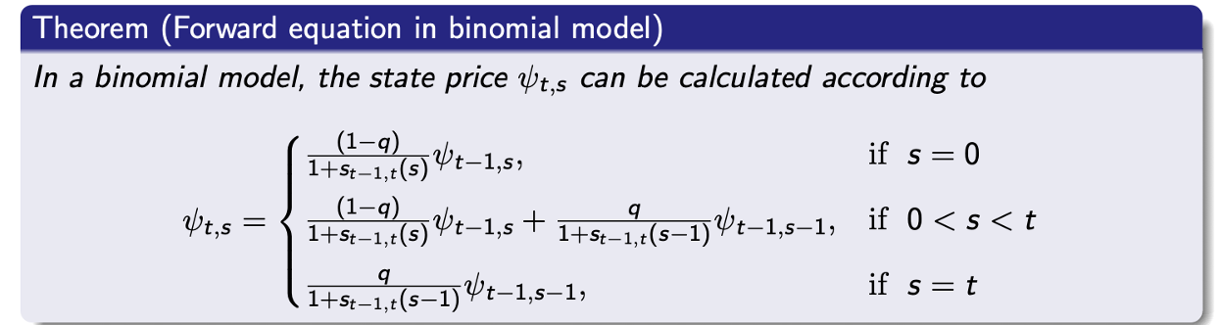
in excel
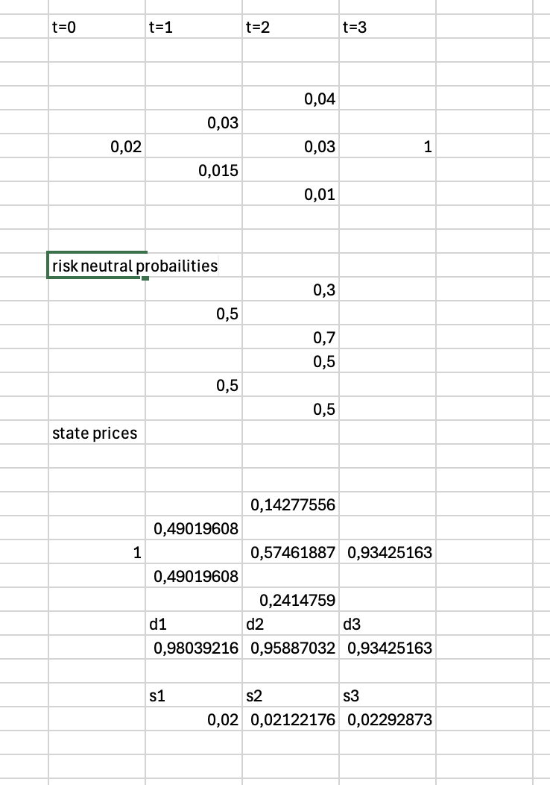

Q2
This also gives us a discountfactor vector
$$d=\left(\begin{aligned}0.9804 \\ 0.9589 \\ 0.9343\end{aligned}\right)$$
We write up the payment stream of the serial bond with the cupon as “a”
$$B^{'}=\left(\begin{matrix}\frac{1000}{3}+1000·a & \frac{1000}{3}+\frac{2}{3}·1000·a & \frac{1000}{3}+\frac{1}{3}·1000·a\end{matrix}\right)$$
And price this
$$\left(\begin{matrix}\frac{1000}{3}+1000·a & \frac{1000}{3}+\frac{2}{3}·1000·a & \frac{1000}{3}+\frac{1}{3}·1000·a\end{matrix}\right)\left(\begin{aligned}0.9804 \\ 0.9589 \\ 0.9343\end{aligned}\right)=1931,1·a+957,867$$
Wh then determine the rate
$$1931,1·a+957,867=1015$$
$⇕$ Ligningen løses for a vha. WordMat.
$$a=0,03$$

Then a 6.1 precent cupon
$$a=3\%$$

Q3 assuming that we exercise after the 2. Payment
Then the only remaining payment is
$$\frac{1000}{3}·\left(1+0.0296\right)=343,2$$
One time from now
We price this cashflow in the 3 different states
Up
$$\frac{343,2}{1.04}=330$$
Middel
$$\frac{343,2}{1.03}≈333,204$$

Down
$$\frac{343,2}{1.01}≈339,802$$

$$c_{0}=0.9589·\left(\left(333,204-332\right)·\left(0.5·0.7+0.5·0.5\right)+\left(339.802-332\right)·{0.5}^{2}\right)≈2,563$$

$$p_{0}=c_{0}-B_{0}+X·d_{2}$$
B_0 in this case Is only the last payment at time 3
With the pirce
$$B_{0}=d_{3}·343,2=0.9343·343.2≈320,652$$

$$p_{0}=2,563-320,652+332·0.9589≈0,266$$

Q5
$$G_{0,2}=E^{Q}\left[B_{2}\right]$$
We take the values of the laset payment in each state from before
$$E^{Q}\left[B_{2}\right]=\left(333,204\right)·\left(0.5·0.7+0.5·0.5\right)+\left(339.802\right)·{0.5}^{2}+330·0.5·0.3≈334,373$$
Q6
$$F_{2}=E^{Q}\left[B_{2}\right]+\frac{cov\left(B_{2},d_{0,T}\right)}{d_{2}}>E^{Q}\left[B_{2}\right]=G_{0,2}$$
Da er forwarden for billig, vi køber forward og sælger future

Vi har ikke dækkede den egentlge strategi i undervisningen men et bevis med martingale prissætning af G som viser det er den eneste rigtige pris og generelt ved vi
$$P_{0}=E^{Q}[d_{t}·P_{t}]$$
Exercise 4
$$μ=\left(\begin{aligned}0.06 \\ 0.08 \\ 0.1\end{aligned}\right), Σ=\left(\begin{matrix}0.0144 & 0.018 & 0.0234 \\ 0.018 & 0.04 & 0.0330 \\ 0.0234 & 0.033 & 0.09\end{matrix}\right)$$
Q1
I would calculate the sharp of each and choose the one with highest
Asset 1
$$\frac{0.04}{\sqrt{0.0144}}≈0,333$$

Asset 2
$$\frac{0.06}{\sqrt{0.04}}=0,3$$

Asset 3
$$\frac{0.08}{\sqrt{0.09}}≈0,267$$

Meaning I choose asset 1 to invest all my money (and more if a bankloan is available) into since it has the highest “return per risk”
Q2
$$w_{1}=\frac{1}{\sqrt{0.0144}}≈8,333$$
$$w_{2}=\frac{1}{\sqrt{0.04}}=5$$
$$w_{2}=\frac{1}{\sqrt{0.09}}≈3,333$$
$$w=\frac{\left(\begin{aligned}8,333 \\ 5 \\ 3.333\end{aligned}\right)}{8,333+5+3.333}≈\left(\begin{matrix}0,5 \\ 0,3 \\ 0,2\end{matrix}\right)$$
$$σ_{p}^{2}=transpose\left(\left(\begin{matrix}0,5 \\ 0,3 \\ 0,2\end{matrix}\right)\right)\left(\begin{matrix}0.0144 & 0.018 & 0.0234 \\ 0.018 & 0.04 & 0.0330 \\ 0.0234 & 0.033 & 0.09\end{matrix}\right)\left(\begin{matrix}0,5 \\ 0,3 \\ 0,2\end{matrix}\right)≈0,025$$
$$μ_{p}=transpose\left(\left(\begin{matrix}0,5 \\ 0,3 \\ 0,2\end{matrix}\right)\right)\left(\begin{aligned}0.06 \\ 0.08 \\ 0.1\end{aligned}\right)≈0,074$$
Q3

Minimum varians:
$$w_{mvp}=\frac{Σ^{-1}·I}{IΣ^{-1}·I}$$
$$w_{mvp}=\left(\begin{aligned}1.29 \\ -0.15 \\ -0.14\end{aligned}\right)$$
$$μ_{mvp}=transpose\left(\left(\begin{aligned}1.29 \\ -0.15 \\ -0.14\end{aligned}\right)\right)\left(\begin{aligned}0.06 \\ 0.08 \\ 0.1\end{aligned}\right)≈0,051$$
$$σ_{mvp}^{2}=transpose\left(\left(\begin{aligned}1.29 \\ -0.15 \\ -0.14\end{aligned}\right)\right)\left(\begin{matrix}0.0144 & 0.018 & 0.0234 \\ 0.018 & 0.04 & 0.0330 \\ 0.0234 & 0.033 & 0.09\end{matrix}\right)\left(\begin{aligned}1.29 \\ -0.15 \\ -0.14\end{aligned}\right)≈0,013$$
$$σ_{mvp}=\sqrt{0,013}≈0,114$$

Q4 tangency portfolio
$$w_{tan}=\left(\begin{aligned}0.6914 \\ 0.2078 \\ 0.1009\end{aligned}\right)$$
$$μ_{tan}=transpose\left(\left(\begin{aligned}0.6914 \\ 0.2078 \\ 0.1009\end{aligned}\right)\right)\left(\begin{aligned}0.06 \\ 0.08 \\ 0.1\end{aligned}\right)≈0,068$$
$$σ_{tan}^{2}=transpose\left(\left(\begin{aligned}0.6914 \\ 0.2078 \\ 0.1009\end{aligned}\right)\right)\left(\begin{matrix}0.0144 & 0.018 & 0.0234 \\ 0.018 & 0.04 & 0.0330 \\ 0.0234 & 0.033 & 0.09\end{matrix}\right)\left(\begin{aligned}0.6914 \\ 0.2078 \\ 0.1009\end{aligned}\right)≈0,019$$
$$σ_{tan}=\sqrt{0,019}$$
The market price of risk or the sharp ratio is exactly
$$\frac{μ_{tan}-r_{f}}{σ_{tan}}=\frac{0,068-0.02}{0,138}≈0,348$$

Q5 when CAPM is satisfied then $w_{m}=w_{tan}$ and we can easily calculate the betas
$$β=\frac{1}{σ_{m}^{2}}·Σ·w_{m}=\frac{1}{0,0193}·\left(\begin{matrix}0.0144 & 0.018 & 0.0234 \\ 0.018 & 0.04 & 0.0330 \\ 0.0234 & 0.033 & 0.09\end{matrix}\right)\left(\begin{aligned}0.6914 \\ 0.2078 \\ 0.1009\end{aligned}\right)≈\left(\begin{matrix}0,832 \\ 1,248 \\ 1,664\end{matrix}\right)$$
Q6
We easily calculate this with the beta vector
$$transpose\left(\left(\begin{matrix}0,5 \\ 0,3 \\ 0,2\end{matrix}\right)\right)\left(\begin{matrix}0,832 \\ 1,248 \\ 1,664\end{matrix}\right)≈1,123$$

